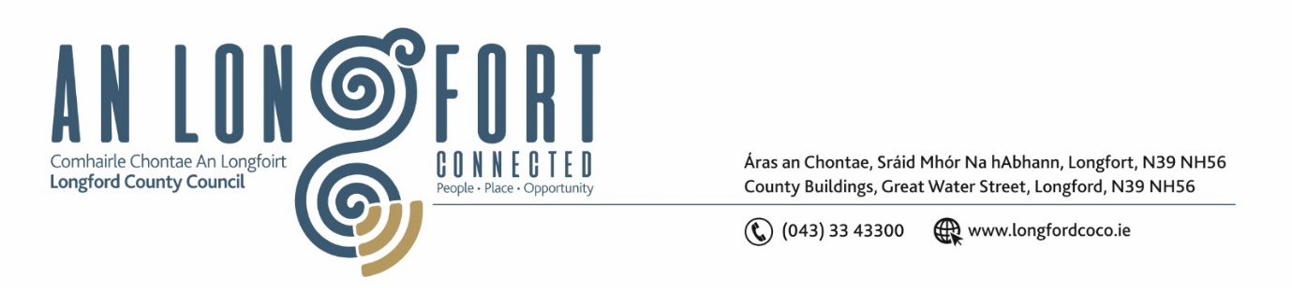

**LONGFORD MUNICIPAL DISTRICT**

**Minutes of Meeting of Longford Municipal District held in the Council Chamber Aras an Chontae and via MS Teams on Wednesday, 22 June 2022 at 3.30pm**

**CATHAOIRLEACH**: Councillor Gerry Hagan

**MEMBERS PRESENT**: Councillors – Seamus Butler, Martin Monaghan, Uruemu Adejinmi, John Browne, Peggy Nolan, and Gerry Warnock

**IN ATTENDANCE**: Mr. John Brannigan, Director of Services

Mr. Eamonn Bennett, Senior Executive Engineer

Ms. Lorraine Mc Kee, Administrative Officer

**MEETINGS**

**ADMINISTRATOR:**  Ms. Ann Marie Mc Keon

**ADOPTION OF MINUTES – circulated**

On the proposal of Councillor Peggy Nolan seconded by Councillor Martin Monaghan, it was unanimously agreed to adopt Minutes of Meeting of Longford Municipal District held on the 25 May 2022.

On the proposal of Councillor John Brown seconded by Councillor Seamus Butler, it was unanimously agreed to adopt Minutes of Committee Meeting of Longford Municipal District held on the 25 May 2022.

**MATTERS ARISING FROM MINUTES**

None.

**DECLARATION OF INTEREST BY MEMBERS**

None.

**MANAGEMENT REPORT INCORPORATING AREA ENGINEER’S PROGRESS REPORT – circulated**

Senior Executive Engineer, Eamonn Bennett highlighted the works in the area since the last meeting and noted the upcoming works. The members raised questions on the following which the executive responded to:

* Skate Park
* HGV Detour
* Regeneration works
* Footpath works
* Broadband works and reinstatement of footpaths

**COMMUNITY GRANT SUPPORT SCHEME 2022 / MUNICIPAL DISTRICT GRANT – AS CIRCULATED.**

On the proposal of Councillor Seamus Butler, seconded by Councillor Peggy Nolan the members unanimously agreed that €1,900 be allocated to Peter Keenan Longford Branch.

On the proposal of Councillor Seamus Butler, seconded by Councillor Peggy Nolan the members unanimously agreed that €4,900 be allocated to Cruthu Arts Festival.

On the proposal of Councillor Seamus Butler, seconded by Councillor Peggy Nolan the members unanimously agreed that €25,000 be allocated to Longford Tidy Towns.

**Consideration of Part VIII – Number 91- Conversion of an existing former healthcare facility to**

**two number two-bedroom dwellings and all ancillary works at 2 Woodview, Newtownforbes County Longford in Accordance with Section 179 of the Planning and Development Act 2000 (as amended) and Part 8 of the Planning & Development Regulations 2001 (as amended) – as circulated**

On the proposal of Councillor John Browne, seconded by Councillor Martin Monaghan the members unanimously agreed to adopt the Part VIII Number 91 Conversion of an existing former healthcare facility to two number two-bedroom dwelling as per report circulated.

**NOTICES OF MOTIONS**

**Temporary Posters**

The following Notice of Motion was proposed by Councillor Seamus Butler and seconded by Councillor Martin Monaghan -

‘That Longford Municipal District adopts a strict protocol on temporary postering for events and other purposes. This protocol should include permitting, number of posters, duration of posters, how and where they are attached and a removal period among others that are open to suggestions’

**Response**

Longford County Council Environment Section’s policy on Temporary Signage was amended in 2017 in relation to a number of aspects including enforcement.   This current policy is in line with Councillor Butlers request. If there are concerns in relation to temporary signage, these concerns should be submitted to Environment Section at  [environment@Longfordcoco.e](mailto:environment@Longfordcoco.e).  or telephone number 043 33433462. In most cases where the attention of Environment Sections is drawn to such concerns, engagement with the party responsible for the signs usually resolves the matter however unauthorised signage will be removed by the Litter Warden staff in accordance with the enforcement aspect of the said policy.

**Footpath on Dublin Street**

The following Notice of Motion was proposed by Councillor Gerry Hagan and seconded by Councillor Peggy Nolan -

"I call on Longford MD to carry out repairs & replacement on the pavement slabs on the footpaths on New Street and Dublin Street. The pavement slabs are in a very dangerous state currently and the paths are a serious hazard to all pedestrians and business who operate along these very busy streets."

**Response**

Longford County Council has an annual programme in place for replacing footpaths. The footpaths on Dublin Street and New Street are included in the current footpath replacement works programme funded by Irish Public Bodies. Longford County Council will replace the existing paving slabs with a concrete footpath. The works will start at end of this year or early next year weather permitting.

Best Wishes

The members wished Jessica Thompson Journalist good luck in her new role, and they also sent best wishes to Brian Mc Neela on his move to the Ballymahon Municipal District.

This concluded the business of the meeting.

Ann Marie Mc Keon

**Signed: ____________________**

**Ann Marie Mc Keon**

**Meetings Administrator.**

**Confirmed and adopted at Longford Municipal District Meeting held on the 26 July 2022.**

Gerry Hagan

**Signed: _______________**

**Cathaoirleach.**